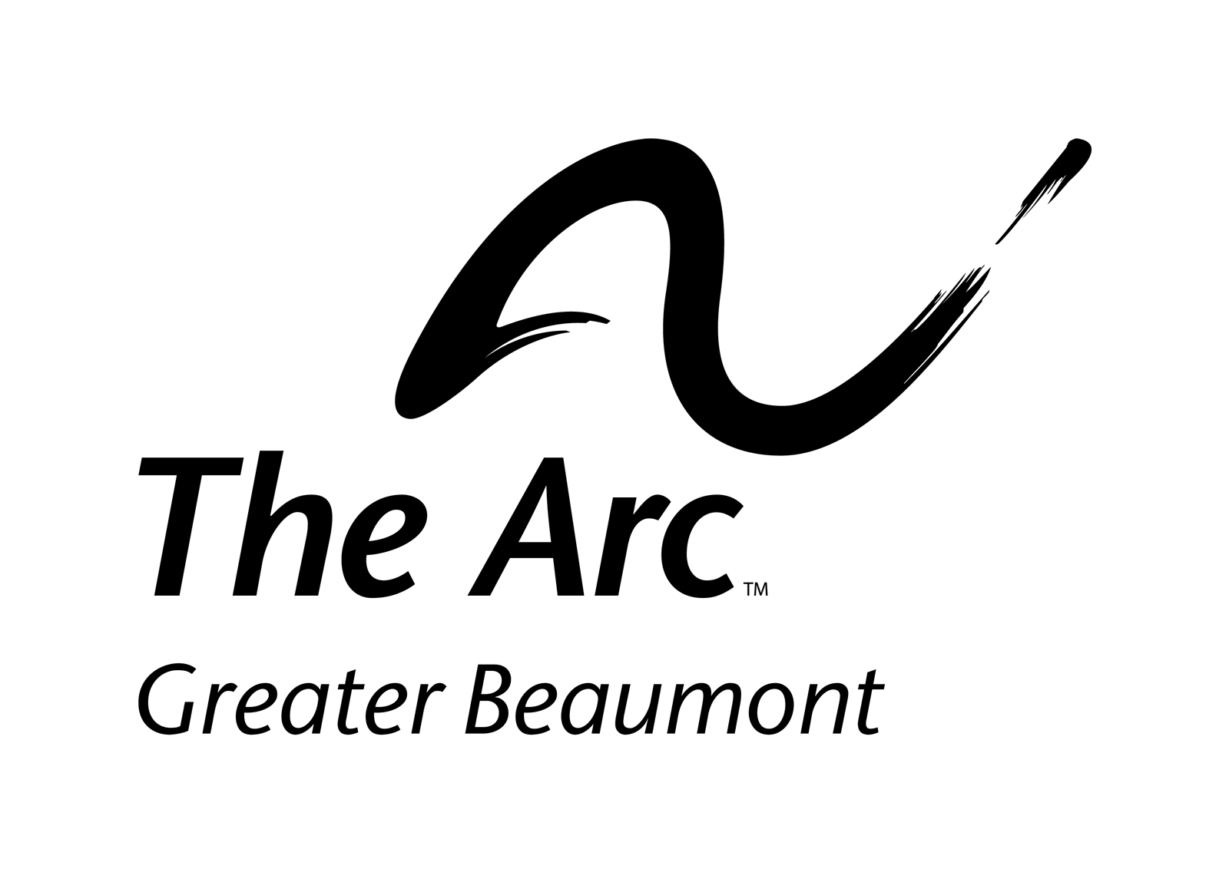
Volunteer Application
Yes, I want to volunteer!

Name: _______________________________________________________________________
Mailing Address: _______________________________________________________________
E-mail Address: ___________________________ Phone Number: _______________________
Date of Birth: ____________________ Social Security Number: _________________________
Areas of Interest (check all that apply):
□ Serve on a planning committee for the following fundraisers:
□Stars of The Arc Celebrity Style Show & Dinner □The Beaumont Buddy Walk
□Step up for Autism Awareness Event □The Arc’s Capital Campaign
□ Serve on the advisory committee for the following programs:
□ Adult Social Club & Dances □ Autism Support Group
□ Down Syndrome Family Group □ Southeast Texas Self Advocates
□ Provide manpower at The Arc’s events.
□ Chaperone/ provide supervision for consumers at The Arc’s activities
□ Mentor the parent of a child with a disability who seeks emotional support and guidance.
I want to help with these events (check all that apply):
□ Arc Adult Social Nights □ Arc Summer Day Camp
□ Autism Support Group Events □ Down Syndrome Family Group Events
□ The Beaumont Buddy Walk □ Stars of The Arc Celebrity Style Show & Dinner
Please tell us briefly why you want to volunteer for the Arc: _____________________________
______________________________________________________________________________Applicants must be 16 years of age or older.
By submission of this application, applicants grants permission to the Arc of Greater Beaumont to conduct a criminal background check.
Upon receipt of this application, applicant will be issued a copy of the Arc Volunteer Policy.

Submit Volunteer Application to The Arc of Greater Beaumont:
Email- caitlin.kruger@arcofbmt.org
Fax- 1-409-515-1129
Mail- The Arc of Greater Beaumont 700 North St. Suite Q Beaumont, TX 77701

